Automated Digitalised Monitoring, Reporting and Verification (D-MRV) system for e-mobility projects

Background
Monitoring, reporting, and verification (MRV) systems for climate outcomes will support decision-making and disclosure during this transition, as well as enable implementation of innovative climate finance solutions to drive decarbonisation of key economic sectors.

The Bank is currently developing a programme that would help its countries of operation to accelerate the mass adoption of electric vehicles (EV), by promoting the transfer of emerging electric mobility technologies, thereby increasing their market penetration. This will directly lead to reduced greenhouse gas (GHG) emissions through the substitution of internal combustion vehicles utilising fossil-based motor fuels with EVs using electric energy.

One of the instruments considered for deployment under the programme is a results-based payment structure wherein payments to electric bus (e-bus) operators would be linked to the actual GHG savings achieved by e-buses which are effectively proportionate to the mileage driven by e-buses. Such a payment structure would encourage the operator of the municipal fleet to optimise the utilisation of the new e-buses and maximise the GHG emissions reductions that they generate.

In order to effectively deploy the above results-based payment structure, facilitate implementation of other e-mobility initiatives, and cut transaction costs associated with monitoring and reporting of climate results achieved, the client would like to develop an automated Digitalised Monitoring, Reporting and Verification (D-MRV) system to:
- digitise project monitoring by directly acquiring actual project performance data (i.e. electricity used and km driven by e-buses);
- automate calculation and verification of climate results (i.e. GHG emission reductions) based on a pre-defined methodology;
- streamline reporting of project climate results internally, to donors and other relevant parties for compliance with reporting requirements;
- enable THE CLIENT projects to measure, verify and, where feasible, support issuance of certified environmental attributes (such as carbon credits).

D-MRV system conceptual design
The D-MRV system should be designed and implemented in such a way as to enable performance of all the core MRV functions for e-mobility municipal projects (e-bus, trolleybus), with the system outputs available through dashboard and reports to THE CLIENT and, potentially, climate funds donors that have co-financed the respective projects. The system design should envisage (allow for) direct interconnection to THE CLIENT (and climate finance donor) systems to directly export relevant data (e.g. GHG emissions reduced) in the future.

The figure below illustrates the concept of D-MRV system operation with D-MRV hardware performing direct data measurement, collection and communication on to cloud-based D-MRV software for storage, processing and displaying/reporting:
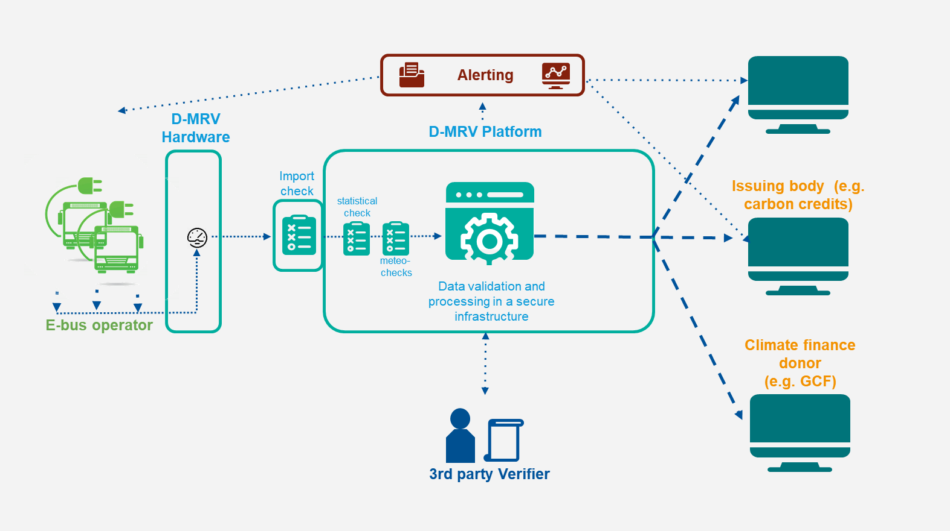
Figure 1: Concepual overview of the D-MRV system

D-MRV system core functions
The figure below shows a conceptual view of the requirements for a digital MRV solution.
Figure 2: Core functions for D-MRV system

The system should perform or, as relevant, support six different functions in the shown order:

- Measurement: Refers to the generation of data through sensing equipment (e.g. electricity meters for electricity used for e-bus charging; GPS sensors for e-bus distance driven).
- Collection: Stands for the collection and concentration of data. Usually performed by a data logger.
- Communication: This function describes the transmission of data from the data logger to the designated server infrastructure. Usually, this is done via GSM or GPRS network. If there is an internet connection on site, it can also be done via Ethernet cabling.
- Storage: Is done on a centralised database. The information can then be accessed through cloud computing or other digital interfaces.
- Processing: Refers to the function of data validation (through automatic cross-checks against GPS data from e-buses, electricity bills from e-bus operator etc.) and calculation of main output variables (i.e. GHG emission reductions). This requires additional data input from other sources than the project itself (e.g. emission factor of the electricity grid used for e-bus charging). Processing should result in displayable, detailed information and key performance indicators.
- Display: Stands for the function of making the processed data digitally accessible for different system participants through various account types in a clear and concise way (through dashboard and reports). Together with storage and processing, this step is executed by a designated piece of software.

D-MRV software
The purpose of the D-MRV software is to ensure that all raw data measured from the hardware installed at the e-bus operator’s side are collected, processed and stored securely at a remote location. Besides the data gathering, the software performs instant data verification tasks and calculates the key output – GHG emission reductions. This process should be fully transparent and traceable for the purpose of auditing by a third-party auditor. The software is the platform, where raw and processed data and documents (e.g. e-bus operator electricity invoices, electricity meter calibration certificates etc.) are stored and where the parties involved can access the datasets and create reports.

D-MRV software functionality
The D-MRV software deployed must be able to receive the measured raw data directly from smart meter, data logger or e-bus operator management system via a secure wireless technology. The data transmitted is encrypted to assure no data tampering between the raw data measured to the secure data storage offsite (i.e. D-MRV database). The D-MRV database should include features such as time-stamped, immutable, append-only data streams for the purpose of traceability (i.e. a third-party auditor should be able see the original raw data based on which GHG emission reduction calculations were performed). Such a feature for data attestation and verification purposes adds credibility to the D-MRV approach to ensure that the data used in the emission reduction calculations is real and compatible with the original data source (addressing potential concerns about data manipulation).

After the transmission, several data verification checks will be run to verify the imported data towards authenticity, completeness, consistency and accuracy. In case of any abnormality during such cross-checks, error messages will be generated via different communication channels (e.g. email, SMS). After the validation run, the data will be processed with a calculation engine that determines the overall GHG emission reduction based on the raw data (i.e. electricity used for e-bus charging from electricity meters and distance driven from GPS trackers) and applicable input data (i.e. emission factors for grid electricity, estimated fuel consumption for reference diesel buses being replaced, etc.) in line with the pre-defined methodology. To ensure traceability and auditing capability, the processed data will be stored in a separate part of the D-MRV database. This allows that all calculation steps can be verified and checked comprehensively at any time. The processed data is then displayed on a graphical web-based user interface (GUI). This function would allow different user groups to easily see, interpret and even audit the datasets at any time. Additionally, the software allows to upload documents (e.g. electricity meter calibration reports, e-bus operator electricity invoices etc.) to the data storage of the corresponding site and are accessible via the GUI. The software will also have an extended reporting function to create predefined reports which are based on templates customizable for different users (e.g. THE CLIENT , climate finance donor, carbon certification etc).

D-MRV software components
The D-MRV software solution will consist of different software components. The main components that need to be developed are described below:
- API enables interoperability between the D-MRV system and external applications (e.g. THE CLIENT data warehouse) which could consume either raw or processed data generated by the D-MRV system;
- D-MRV database is aggregating raw data received from the data logger and network of sensors/meters onsite and is also storing the processed data; all data transfers to and from the database will include standard safety features (encryption, time stamping etc.) to avoid data tampering;
- Calculation engine performs validation and integrity checks and determines the overall emission reduction based on the raw data and emission factor input;
- Communication interface is able to send alarms to relevant project parties (depending on the nature of the system alarm) by email or SMS in case of data gaps, malfunction of the system or non-compliance with integrity checks;
- Upload function will allow to upload external data to the database in structured and categorised way (e.g. documents such as calibration reports or invoices (in PDF) or other datasets like grid emission factors); the documents can be accessed and checked by the third-party auditor for the purpose of system verification;
- Monitoring dashboard is the graphical interface, where processed data can be displayed and consumed remotely in a user-friendly way; and
- Reporting function that enables the generation (automatically and manually) and export of reports in different file formats (e.g. CSV, excel, word, PDF) and in line with customizable monitoring report templates.

Further considerations
Subject to relevant provisions of THE CLIENT procurement policy, the intellectual property rights for the final D-MRV software product developed shall be with the THE CLIENT .

